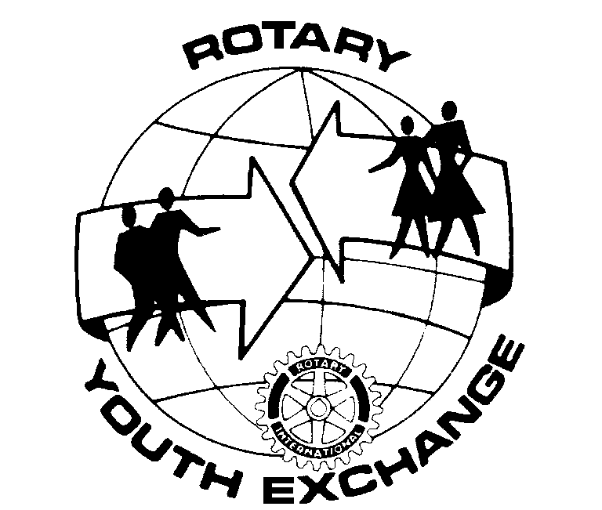
Rotary Club of ________________
Youth Exchange Committee
District 5100, located in Oregon and Washington, USA
“The Future of Rotary is in Your Hands”

SUGGESTED PLACES TO VISIT

Have your inbound student speak at each meeting. Have he or she report what they have done during the past week. Just as important have the student mention what they have not done yet.

ONE DAY OUTINGS

- Gorge Area
- Hike to the top of Multnomah Falls.
- Vista House for pictures.
- Bonneville Dam, visit Herman the Sturgeon
- Rooster Rock State Park.
- Mount Hood
- Timberline Lodge – visit or ski
- Barlow Trail
- Fall and Spring day hikes from Government Camp.
- Coast Area
- Lighthouses, Lincoln City to Newport.
- Kite Flying
- Cape Kiwanda, Pacific City.
- Fort Stevens, Astoria.
- Fort Clatsop, Astoria.
- Astoria Column, Astoria.
- School where “Kindergarten Cop” was filmed, Astoria.
- Aquarium, Newport.
- Depot Bay, Seaside.
- Ripleys Believe it or Not, Newport.
- Seaside.
- Cannon Beach.
- Whale Watching, Depot Bay (seasonal)
- Fall salmon fishing, Warrenton.
- Walking tours within your city.
- Champoeg Park
- Capital Building, Salem.
- Oregon City
- Oregon City Falls.
- Historical Homes.
- End of the Trail Interpretative Museum.
- Portland Metro Area
- Ride Max for free in “fairless square”
- Pioneer Square
- Portlandia.
- Portland State University.
- PGE Park.
- Lloyd Center – Ice Skating.
- Clackamas Town Center – Shopping.
- Washington Square – Shopping.
- Oregon Zoo.
- Japanese Gardens.
- Washington Park.
- China Town.
- OMSI.

WEEKEND OR LONGER TRIPS

Check with host family before making plans.

- Combine several of the day outings, to make a weekend.
- Bend Area.
- Lava Caves.
- High Dessert Museum.
- Mt Bachelor Skiing.
- Sun River.
- White water rafting.
- Prineville Railroad.
- Newberry Crater.
- Camp Sherman, Metolis River Area.
- Hiking.
- Coast – see day outings.
- Eastern Oregon – its all good.
- Pendleton Round Up.
- Wallowa County.
- Burns.
- Fossil.
- Sumpter – gold dredge.
- Strawberry Mountains.
- Hells Canyon.
- Southern Oregon
- Crater Lake.
- Lava tubes.
- Klamath Falls to Mount Shasta.
- Ashland – Shakespeare Plays.
- Mt Ashland – Skiing.
- Rogue River Jet Boats.
- Seattle
- Space Needle.
- Pacific Science Center.
- The Music Experience.
- Monorail.
- Waterfront Area – Pikes Fish Market.
- Puget Sound Ferry Rides.
- Boeing Museum.
- San Francisco
- Golden Gate Bridge.
- Alcatraz.
- Hard Rock Cafe.
- Fishermans Wharf.
- Cable Cars.
- Chinatown.

